CROSS-SECTIONS

A _________________________ is the two-dimensional shape that you get when you slice through a three-dimensional figure, the intersection of a plane and a solid.

A three-dimensional figure can have many different cross-sections. It all depends on the _____________ or
________________ of the slice.

________________: an oval figure

SOLID | parallel to base | perpendicular to base | at a slant to the base
rectangular prism | 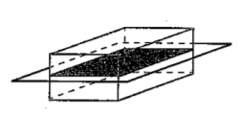  cross section: _______________ | 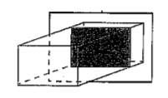  cross section: _______________ | 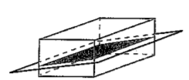  cross section: _______________
rectangular pyramid | 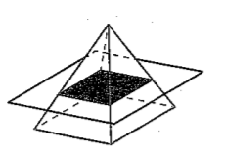  cross section: _______________ | goes through top vertex  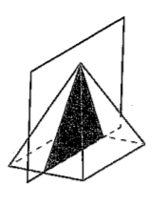  cross section:  ______________  doesn’t go through top vertex  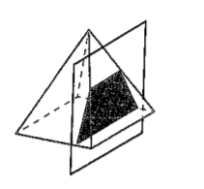  cross section: _______________ | 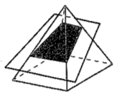  cross section: _______________
cylinder | 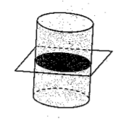  cross section: _______________ | 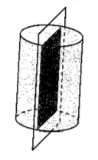  cross section:  ______________ | 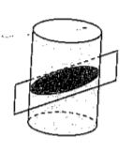  cross section: _______________
cone | 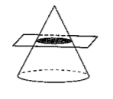  cross section: _______________ | goes through vertex  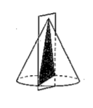  cross section:  ______________ | 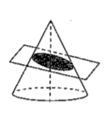  cross section: _______________

Name the shape formed by each cross-section.
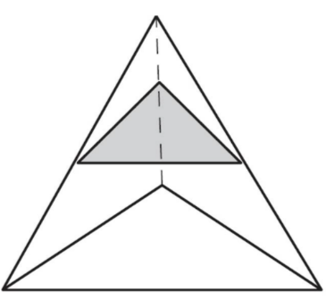 | 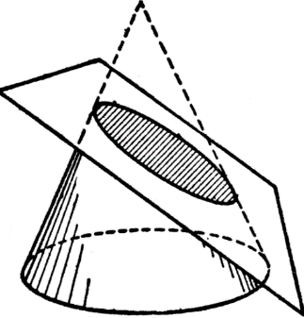
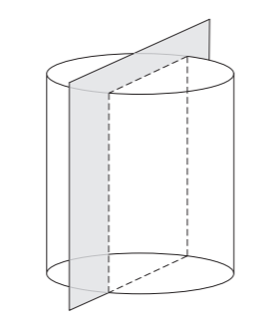 | 