NAME: _______________________________________________ PERIOD: _______ DATE:___________
ANGLES STUDY GUIDE – MATH 6A
PART 1 (Multiple Choice): Circle the correct answer.
1. What is the classification of the pair of angles shown?  A.) supplementary  B.) vertical  C.) complementary  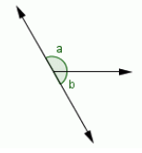 | 2. What is the classification of the pair of angles shown?  A.) supplementary  B.) vertical  C.) complementary  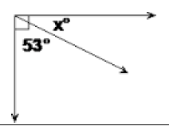
3. What is the classification of the pair of angles shown?  A.) supplementary  B.) vertical  C.) complementary  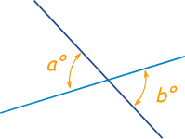 | 4. What is the measure of angle X?  A.) 115 degrees  B.) 65 degrees  C.) 90 degrees  D.) 180 degrees  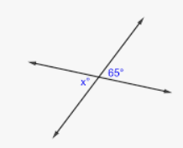
PART 2 (Short Answer): Show all work.
5. Set up & solve an equation to find the measure of angle x.  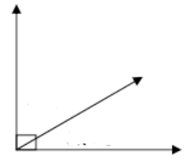  72.6$°$  x  measure of angle x = _________ degrees | 6. Set up & solve an equation to find the measure of angle m.  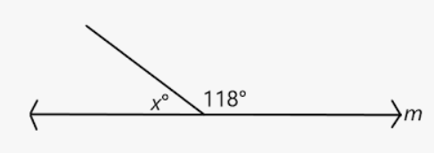  measure of angle m = _________ degrees
7. Set up & solve an equation to find the value of x.  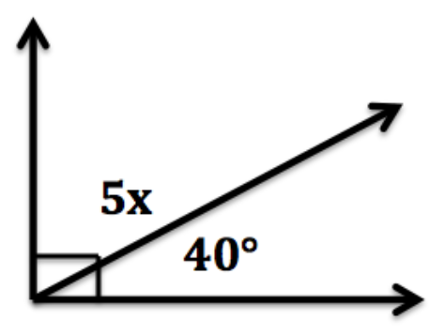  x = ________ | 8. Use your answer from question 7 to find the measure of the missing angle. Show your work.  _________ degrees
9. Set up & solve an equation to find the value of x.  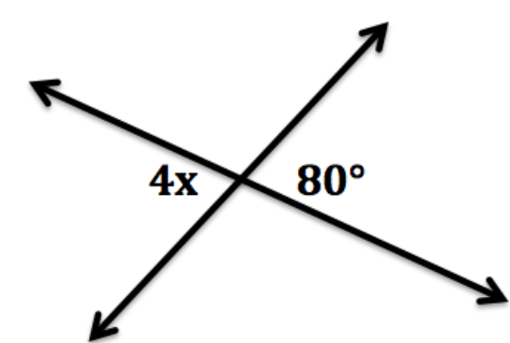  x = ________ | 10. Set up & solve an equation to find the value of x.  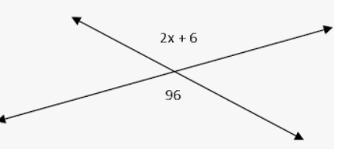  x = ________
11. Set up & solve an equation to find the value of x.  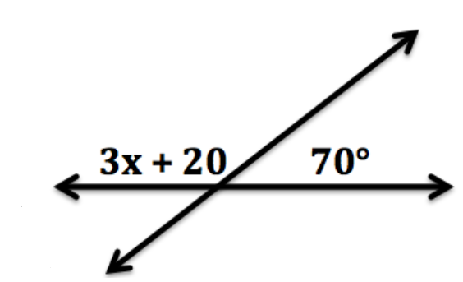  x = ________ | 12. Use your answer from question 11 to find the measure of the missing angle. Show your work.  _________ degrees
13. Set up & solve an equation to find the value of x.  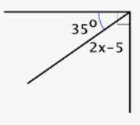  x = ________ | 14. Use your answer from question 13 to find the measure of the missing angle. Show your work.  _________ degrees

