SURFACE AREA OF PRISMS
Complete the F-A-T table to calculate the surface area of each geometric solid. Show all work. Include labels with your answers.
FACES | AREA | TOTAL
front & back
top & bottom
sides

SOLID
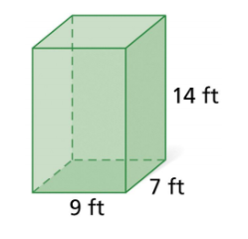

TOTAL SURFACE AREA: _____________________________________
FACES | AREA | TOTAL
Triangles 1 & 2
Rectangle 1
Rectangle 2
Rectangle 3

SOLID
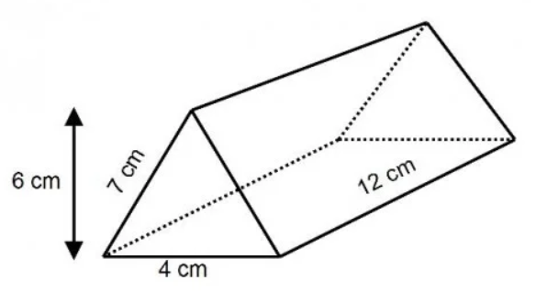

SOLID
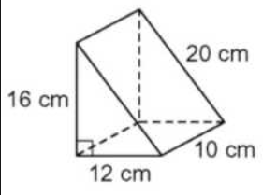

TOTAL SURFACE AREA: _____________________________________

SOLID
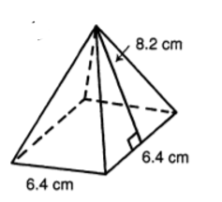

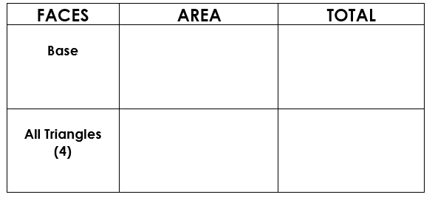

FACES | AREA | TOTAL
Triangles 1 & 2
Rectangle 1
Rectangle 2
Rectangle 3

Total Surface Area:______________________________

